Rivanna – UVA’s High-Performance Computing (HPC) system

- Getting to know Rivanna (Cesar)
Rivanna supercomputer has 575 nodes with over 20476 cores and 8PB of various storage.
Who can access? All UVA faculty, staff, and postdoctoral associates, or students when part of faculty research. More facts about Rivanna ?

- Login into Rivanna (Cesar)
http://rivanna-portal.hpc.virginia.edu

- Tabs on Rivanna (Leonel)
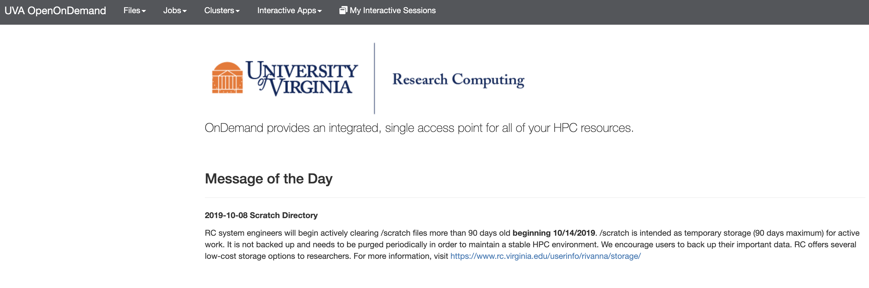

- Opening an R session (Neil)

Details – Mac/Non Mac considerations
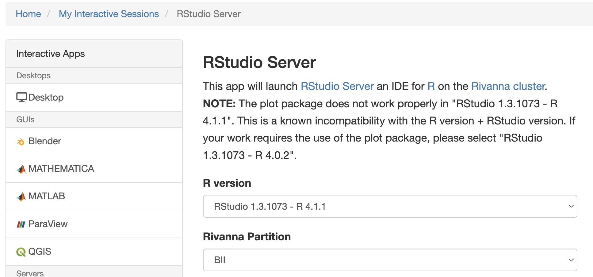

- Rivanna + PGAdmin (Joanna)
- .REnviron
- Explain PGAdmin
- Make an exercise with a database
  - Connect to database
  - Open a file

HANDS ON EXERCISE 1
- 6 students. Individual exercise. Assign Mentors
- Make students open Rivanna.
- Upload a csv file in Rivanna.
- Open it using RStudio

HANDS ON EXERCISE 2
- 6 students. Individual exercise. Assign Mentors
- Make students open Rivanna.
- Open RStudio session
- Check .REnviron
- Then, connect to database.
- Obtain a dataframe from PGAdmin

Q & A

How much space do I have in Rivanna?

How do I check that Rivanna is down/up?
- UVA Research Computing https://www.rc.virginia.edu/

Who can help me if I have any problem?
- Cesar, Kathryn, Neil, Joanna, Hanna, Leonel, Micah …

What if I get a message like?
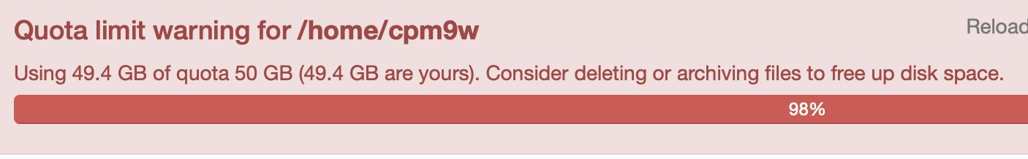

Or like this?

